7) How GIT clone command works?

Git clone allows you to copy and contribute to an existing repository. Cloning gives you access to all the files, including previous versions and data in that particular repository. Cloning makes the files of that repository accessible on your local machine and can work and push offline.

On Git Bash, the command you need to type is “git clone <url>”.

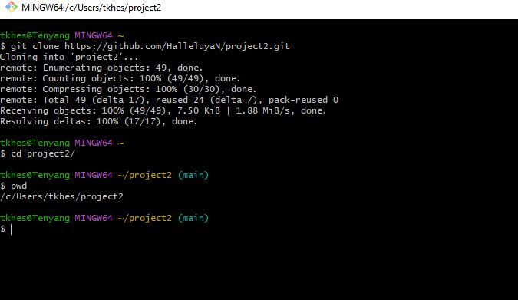

8) How to check GIT update?

Git doesn’t have a specific “update” command. Rather, the process of updating a repository is broken into few different git commands.

* **“git add”** keeps the new file in a staging area, ready to be committed.
* **“git commit”** moves the file from the staging area to the local machine.
* **“git push”** takes the file from the local machine to the remote repository.
* **“git pull”** will allow you to pull the updated repository.